Name:
Class Period: Date:

“Literacy is the ability to use available symbol systems … for the purpose of making and communicating meaning and knowledge.” ~ Patricia Stock, Professor, Michigan State University

- What might be some “symbol systems” that societies through the ages have used to make and communicate meaning and knowledge? List all you can think of.

- How would the fact that books were originally copied by hand affect who had the opportunity to be literate?

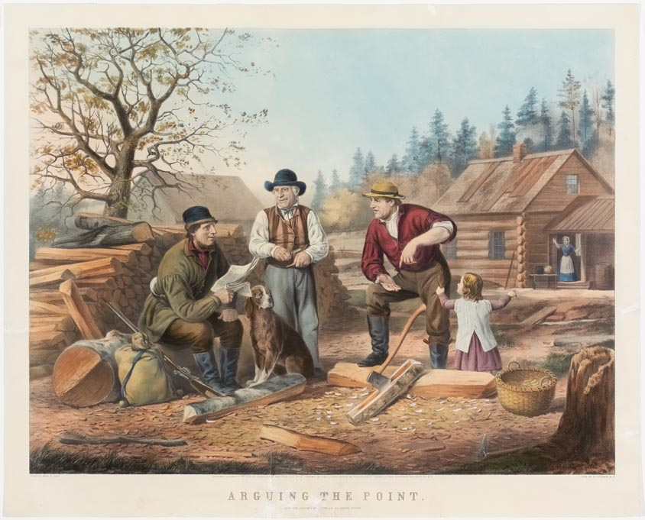

This engraving from 1885 by Nathaniel Currier depicts a scene on the American frontier in which a printed newspaper is being heatedly discussed.

- What does this depiction suggest about literacy at this time?

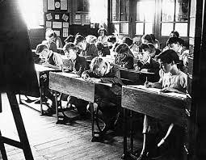

- How is literacy represented differently in this photograph from a classroom in the early 20th Century and in the Currier engraving?

Around 1440 the printing press was invented in the Holy Roman Empire by the German Johannes Gutenberg revolutionizing printing and led to expansions in literacy by making books accessible to the masses.

- To what extent do you think digital communication tools like Facebook, Twitter, Instagram, and others are similar to the Gutenberg press in their effect on what it means to be “literate”?

Literacy Communities:

In this era of human communication, as a user of the Internet, you literally have access to the entire world. Thus, you need to possess multiple literacies and be able to create and communicate knowledge to people of different ages, interests, classes, genders, and backgrounds. These are the distinctions that define what are called “literacy communities,” groups of people who not only share the same language but share the same slang, the same symbols, and the same points of reference. People tend to belong to a number of different literacy communities, and we often switch between these literacy communities effortlessly, though sometimes the switching can cause confusion.

For example, look at the following text message exchange between a mother and her daughter:

Clearly, Mom is not yet completely literate in texting, which causes confusion when she tries to share the same “symbol system” as her daughter. People tend to fall into various “Literacy Communities” based on age, interests, social class, gender, geography, and other factors. As much as the mother in the text above would like to be a part of her daughter’s literacy community, she does not yet understand all of the language found within that community, perhaps due to her age or her lack of experience with texting.

Your Activity: Thinking about Literacy Communities

- Describe the latest movie you saw, game you played, or song you listened to. Write one description of that movie, game, or song to a close friend, one for a parent or grandparent, and one for your teacher who is going to score you based on the level of detail you include in the description. Each description should be a minimum of 8-10 sentences each.

- Afterward, look back at the language choices you made and examine what is similar and different between the pieces. Write a paragraph (8-10 sentences in length) about how your language (diction) choices represent the differences among your literacy communities.

Write each of your paragraph for questions one and two directly into this document. Be sure to identify which description is which.

